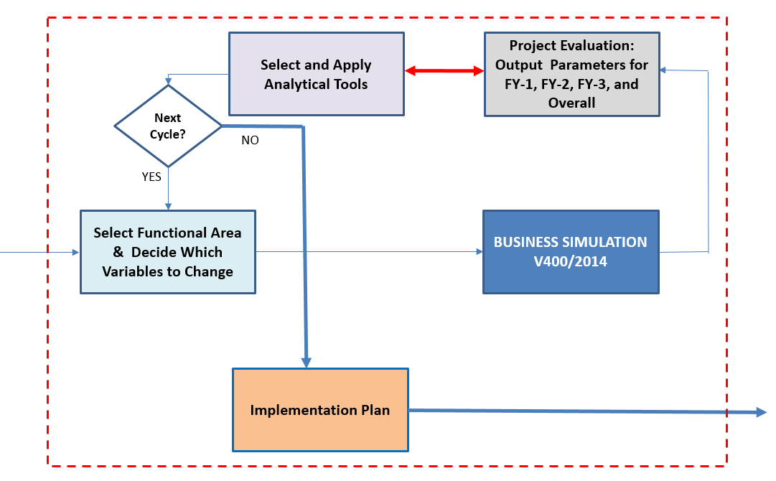

**BUSINESS SIMULATION**

**V401/2020**

**HOW TO PLAY**

**Business Simulation: ‘Strategies and Decision Support in Organizations’**

**PREPARE: HOW TO PLAY**

**BASICS**

**LOCATIONS:**

**Course Website AD715** >>> Home Page >>> Assignments >>> Assignment 3

>>> Business Running Case: Investing in a NewBrewPub? (Conceptual Study by the Owner of an Existing Restaurant/Tavern), PDF

**Course Website AD715** >>> Home Page >>> Required Tutorials

>>> Tutorial for AD715: Business Simulation in MS Excel >>> (Presentation, PDF)

**Download & Read the Tutorial for AD715**: Business Simulation in MS Excel (Presentation)

**Download & Read the Business Running Case**: Investing in a NewBrewPub? (Conceptual Study by the Owner of an Existing Restaurant/Tavern)’

**Course Website AD715** >>> Home Page >>> Required Tutorials

>>> Tutorial for AD715: Business Simulation in MS Excel >>> (Video, downloadable mp4)

**Review the Tutorial for AD715**: Business Simulation in MS Excel (Video)

**PREPARE**

**ANALYZE**

**DECIDE**

**PREPARE: HOW TO PLAY**

**BASICS**

**LOCATIONS:**

**Course Website AD715** >>> Home Page >>> Assignments >>> Assignment 3

>>> Business Simulation: Strategies and Decision Support in Organizations >>> **Help** (PDF)

**Download & Read the Help for the Business Simulation**

**Remote Access to the BU MET Virtual Labs**

<https://www.bu.edu/metit/services/client-technology/virtual-lab/>

**Download the Business Simulation on Your Virtual Computer**

**Recommended Steps:**

1. Remotely access your V-PC

(**Restricted Access**: use your BU ID and BU password)

From the desktop of your V-PC right click on New >>> Folder and create a new folder called ‘AD715-B-Sim’

From the desktop of your V-PC select the folder ‘Class Files’ >>> sub-folder ‘AD715’ and open the sub-folder ‘AD715_Business-Simulation_v401’

Copy the excel files ‘AD715_Business-Simulation_v401.xlsm’ and ‘Financial_Statements.xlsm’ to the newly created folder ‘AD715-B-Sim’

(ii)

(iii)

(iv)

**PREPARE**

**ANALYZE**

**DECIDE**

**PREPARE: HOW TO PLAY**

**BASICS**

**LOCATION:**

**BU MET Virtual Labs >>> Your V-PC >>> Desktop**

**Open the Business Simulation on Your Virtual Computer**

Within the new folder ‘AD715-B-Sim’ open file ‘AD715_B-Sim_v401.xlsm’

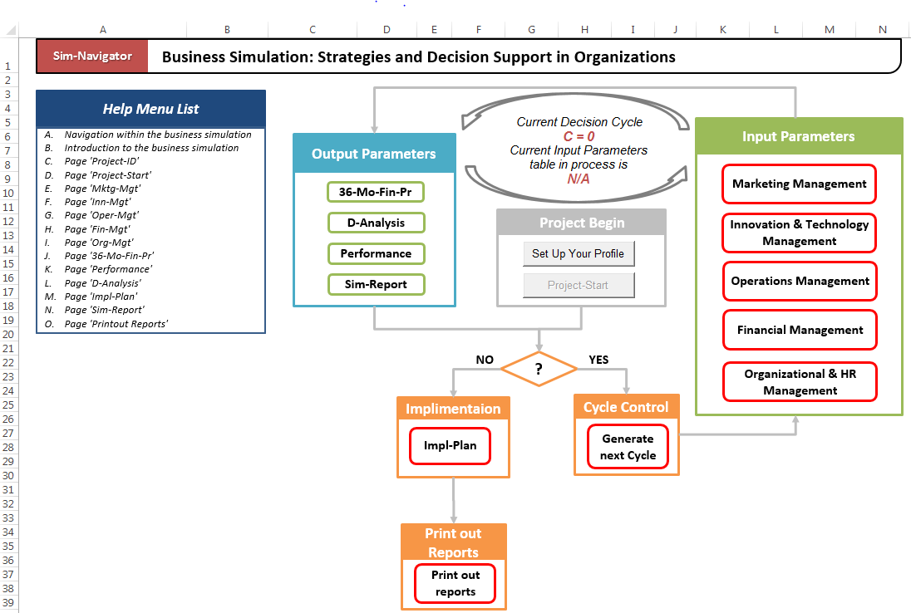

**Important Notes:**

**Note 1.** All files created during your work with the simulation software will automatically be saved in the folder ‘AD715-B-Sim’

**Note 2.** In preparation for your final report (Assignment 3), you have to email selected files from this folder to yourself, and then to submit these files as attachment to the submitted Assignment 3

**PREPARE**

**ANALYZE**

**DECIDE**

**PREPARE: HOW TO PLAY**

**Important Note:**

Yellow cells indicate fields you should edit; others are not editable

**Create your Profile:**

1. **Project Title** In the yellow cell named project title, enter your project title.

2. **Location of the Project** In the yellow cell named project location, enter your business location.

3. **Student Name** In the yellow cell named student name, enter your name.

4. **Submit** Click the submit button to get started.

From the front page **Tab ’Sim-Navigator’**, select ‘Set Up Your Profile’ and the program will open **Tab ‘Project-ID’**.

**DATA ENTRY: CREATE PROFILE**

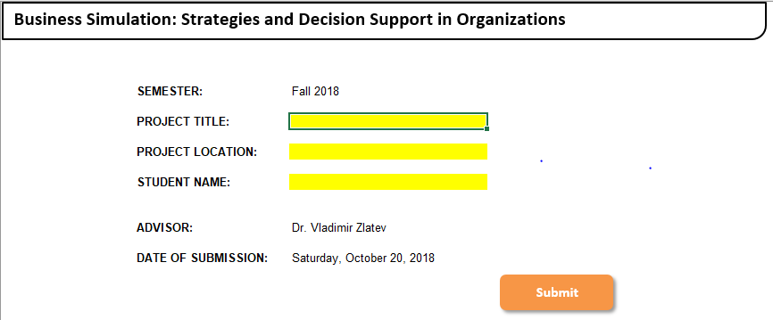



**PREPARE**

**ANALYZE**

**DECIDE**

**PREPARE: HOW TO PLAY**

**DATA ENTRY: SELECT OBJECTIVES**

From the **Tab ’Sim-Navigator’** select ‘Project-Start’ and the program will open **Tab ‘Project-Start’**.

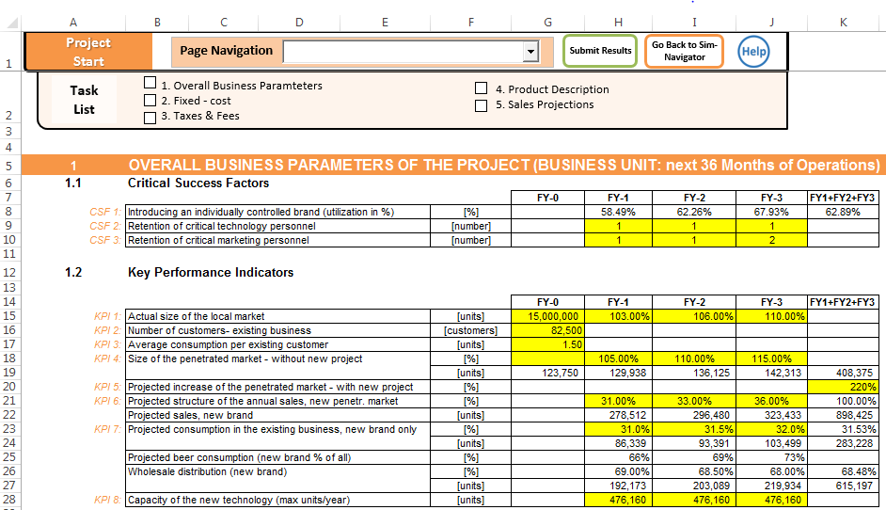

The overall business objectives of the business unit for the next 36 months of operations of this project are presented as

1. **Critical Success Factors** and
2. **Key Performance Indicators**

**LOCATIONS:**

The process of selection of specific values for each one of the overall business parameters is demonstrated with the help of a ‘**Demo-Exercise PART 1: Project Start’**

**Course Website AD715**

>>> Assignments >>> Assignment 3

>>> Demo Exercise, **PART 1**: Project Start (PDF)

**PREPARE**

**ANALYZE**

**DECIDE**

**DECIDE: HOW TO PLAY**

**Tab ‘Sim-Navigator’** is an interactive process diagram where different steps of the managerial decision-making process are connected with arrows, referred to as arcs – each one shows the direction of the influence that the steps have on one other.

**DATA ENTRY: GENERATE DECISION CYCLE**

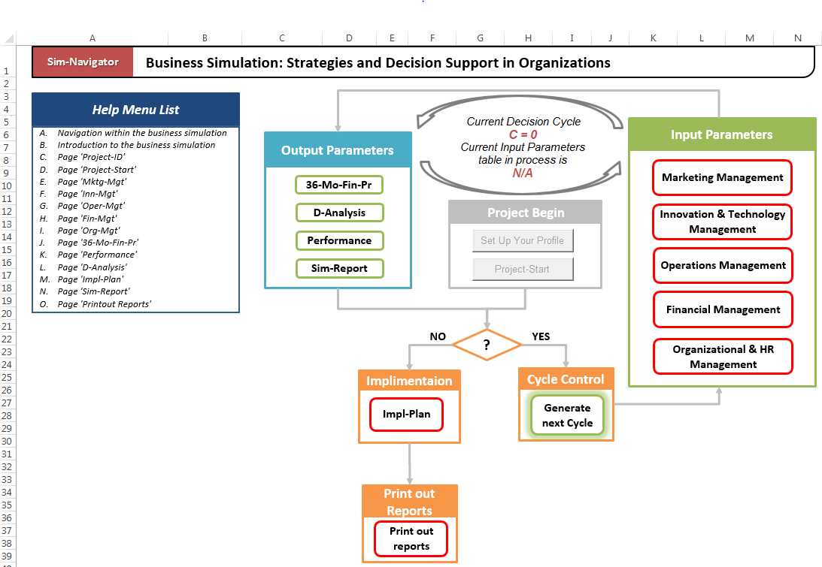

* The **diamond node** depict the decision to generate next decision cycle or to prepare an implementation plan for a selected decision cycle
* By clicking on the **green rectangle node** ‘Generate Next Cycle’, one can start a new cycle for calculation and select one of the several input parameter tables from the **green** **sector ‘Input Parameters’** to work with.

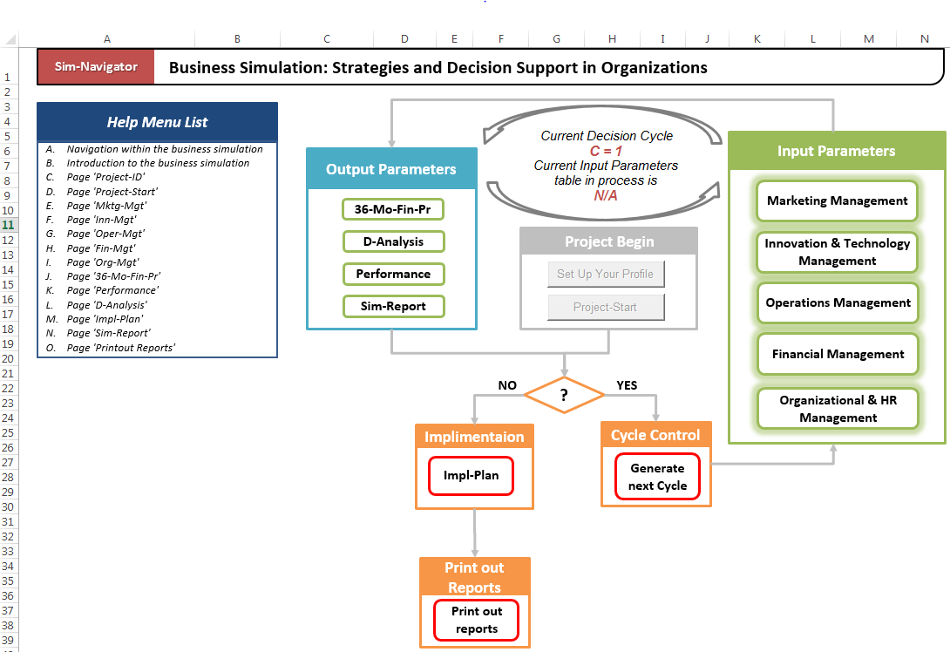

* **Working with one of the selected input parameters table**. If there’s at least one completed cycle, you will be prompted to choose an underlying cycle. The underlying cycle retains data sets from previous decision rounds.

**PREPARE**

**ANALYZE**

**DECIDE**

**DECIDE: HOW TO PLAY**

**DATA ENTRY: MARKETING MANAGEMENT**

**Tab ‘Mktg-Mgt’**

The process of selection of tasks and specific values for different variables is demonstrated with the help of a ‘**Demo-Exercise PART 2: Functional Areas Marketing Management & Innovation Management’**

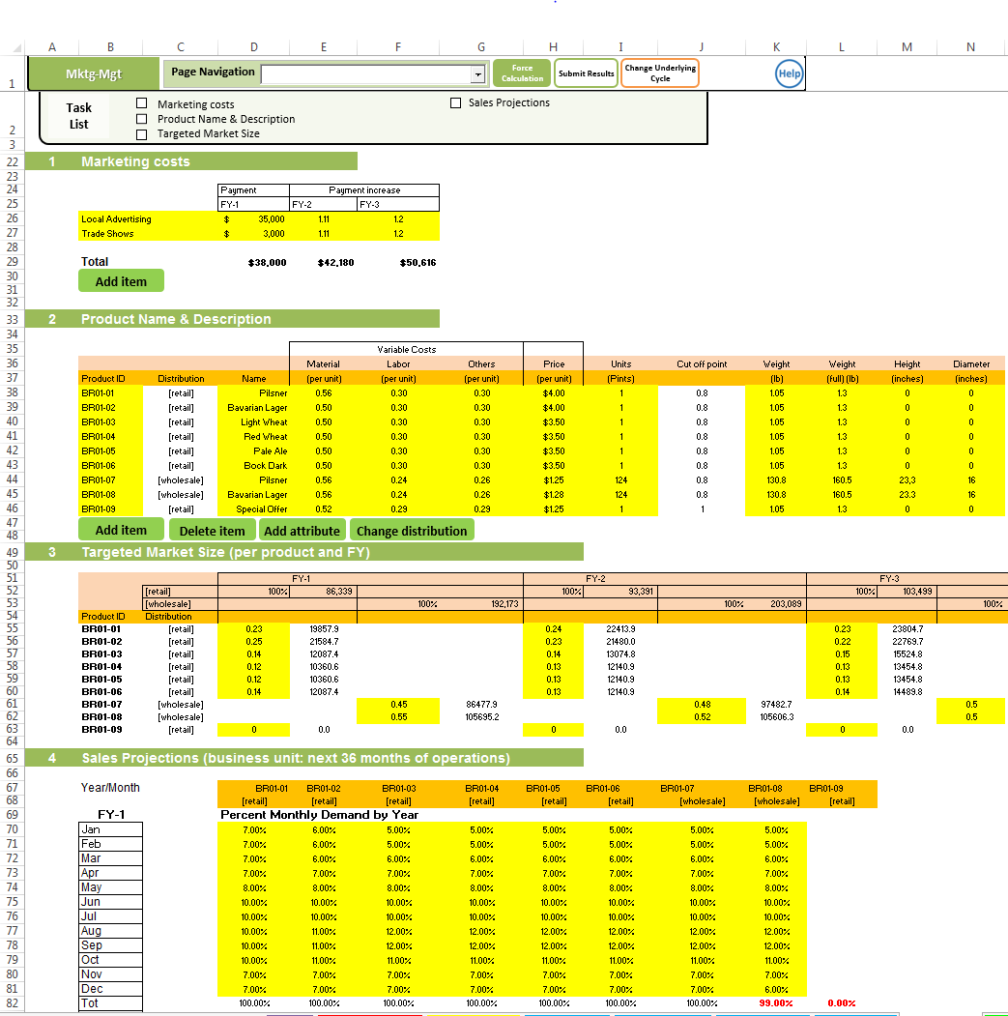

**LOCATION:**

**Course Website AD715**

>>> Assignments >>> Assignment 3

>>> Demo Exercise, **PART 2**: Functional Areas Marketing Management & Innovation Management’ (PDF)

**PREPARE**

**ANALYZE**

**DECIDE**

**DECIDE: HOW TO PLAY**

**DATA ENTRY: INNOVATION & TECHNOLOGY MANAGEMENT**

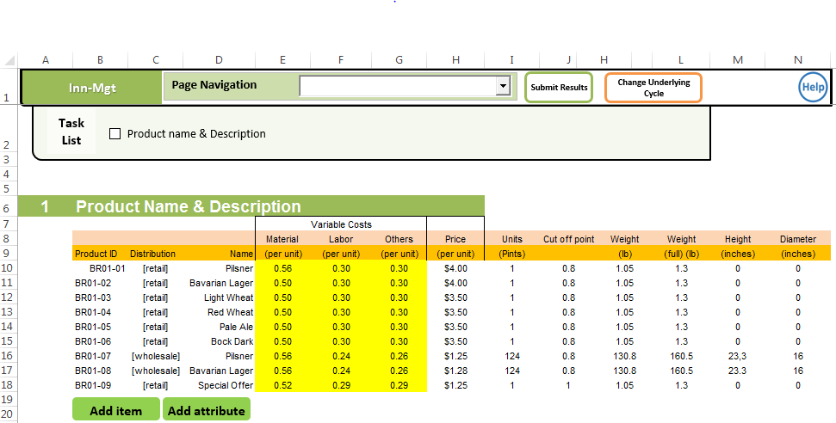

**Tab ‘Inn-Mgt’**

The process of selection of tasks and specific values for different variables is demonstrated with the help of a ‘**Demo-Exercise PART 2: Functional Areas Marketing Management & Innovation Management’**

**LOCATION:**

**Course Website AD715**

>>> Assignments >>> Assignment 3

>>> Demo Exercise, PART 2: Functional Areas Marketing Management & Innovation Management’ (PDF)

**PREPARE**

**ANALYZE**

**DECIDE**

**DECIDE: HOW TO PLAY**

**DATA ENTRY: OPERATIONS MANAGEMENT**

**Tab ‘Oper-Mgt’**

The process of selection of tasks and specific values for different variables is demonstrated with the help of a ‘**Demo-Exercise PART 3: Functional Areas Operations Management & Financial Management & Organizational and HR Management’**

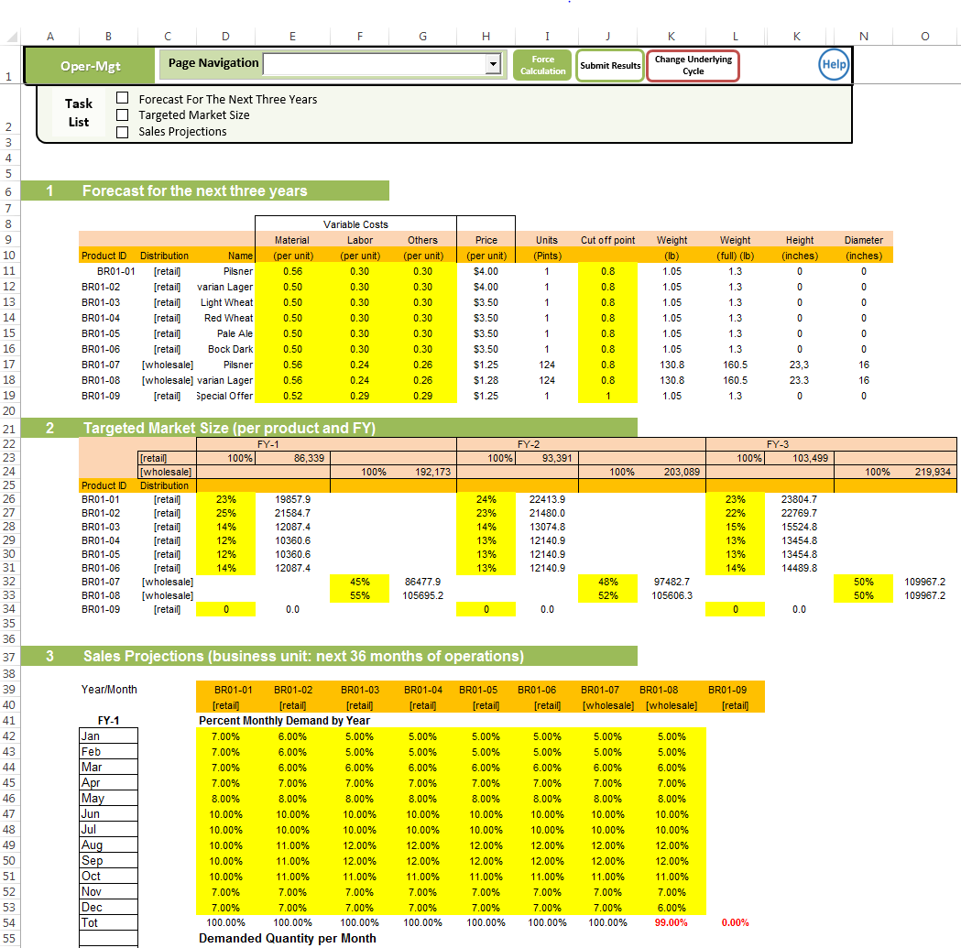

**LOCATION:**

**Course Website AD715**

>>> Assignments >>> Assignment 3

>>> Demo Exercise, **PART 3**: Functional Areas Operations Management & Financial Management & Organizational and HR Management’ (PDF)

**PREPARE**

**ANALYZE**

**DECIDE**

**DECIDE: HOW TO PLAY**

**DATA ENTRY: FINANCIAL MANAGEMENT**

**Tab ‘Fin-Mgt’**

The process of selection of tasks and specific values for different variables is demonstrated with the help of a ‘**Demo-Exercise PART 3: Functional Areas Operations Management & Financial Management & Organizational and HR Management’**

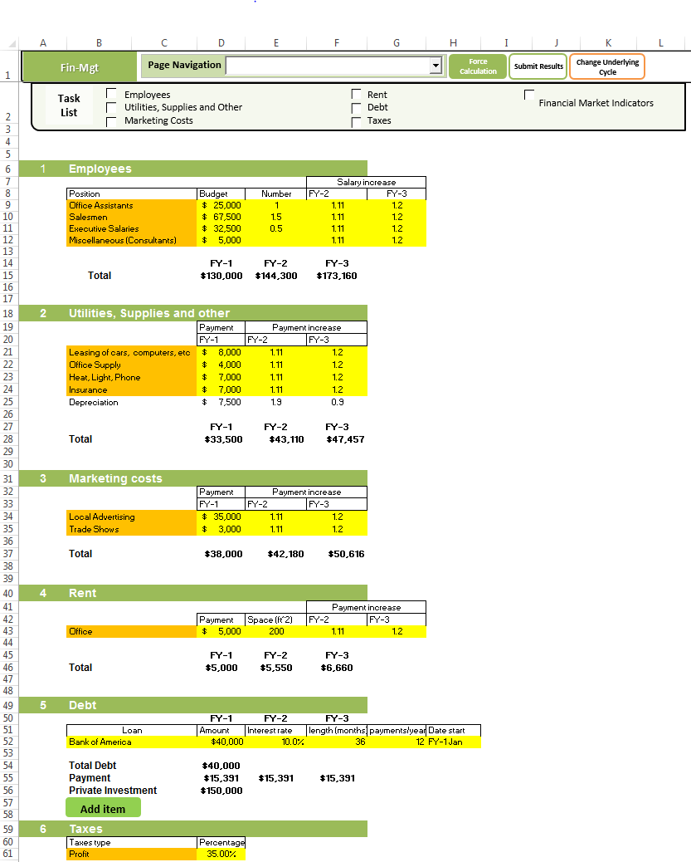

**LOCATION:**

**Course Website AD715**

>>> Assignments >>> Assignment 3

>>> Demo Exercise, **PART 3**: Functional Areas Operations Management & Financial Management & Organizational and HR Management’ (PDF)

**PREPARE**

**ANALYZE**

**DECIDE**

**DECIDE: HOW TO PLAY**

**Tab ‘Org-Mgt’**

The process of selection of tasks and specific values for different variables is demonstrated with the help of a ‘**Demo-Exercise PART 3: Functional Areas Operations Management & Financial Management & Organizational and HR Management’**

**DATA ENTRY: ORGANIZATIONAL & HR MANAGEMENT**

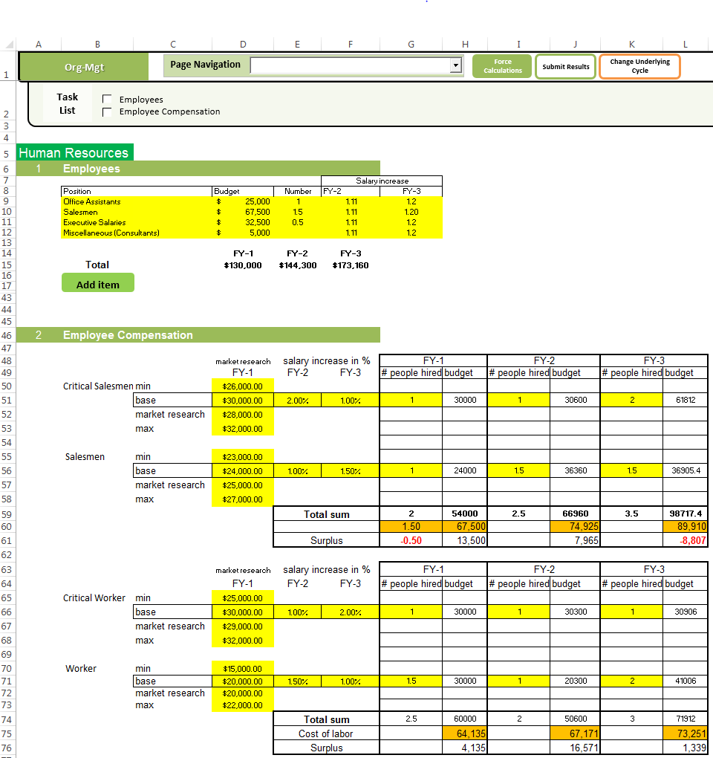

**Course Website AD715**

>>> Assignments >>> Assignment 3

>>> Demo Exercise, **PART 3**: Functional Areas Operations Management & Financial Management & Organizational and HR Management’ (PDF)

**LOCATION:**

**PREPARE**

**ANALYZE**

**DECIDE**

**ANALYZE: HOW TO PLAY**

**ANALYZE: 36 MONTHS FINANCIAL PROFORMA**

By clicking on the green ‘Submit Results’ button located on the top of the window of each one of the tables from the green sector ‘Input Parameters’, your changed assumptions will be in effect and the program will calculate all output parameters for this cycle.

**Tab ’36-Mo-Fin-Pr’**

Once you’ve navigated to this page, as with other output tables, the first thing to do is click “Choose cycle to calculate” and choose a cycle from which to load data. Otherwise the table will not reflect the inputs you intend.

By clicking on the button **‘Create Financial Report’**, three different financial statements will be generated automatically (***see the outlines of the statements, below***).

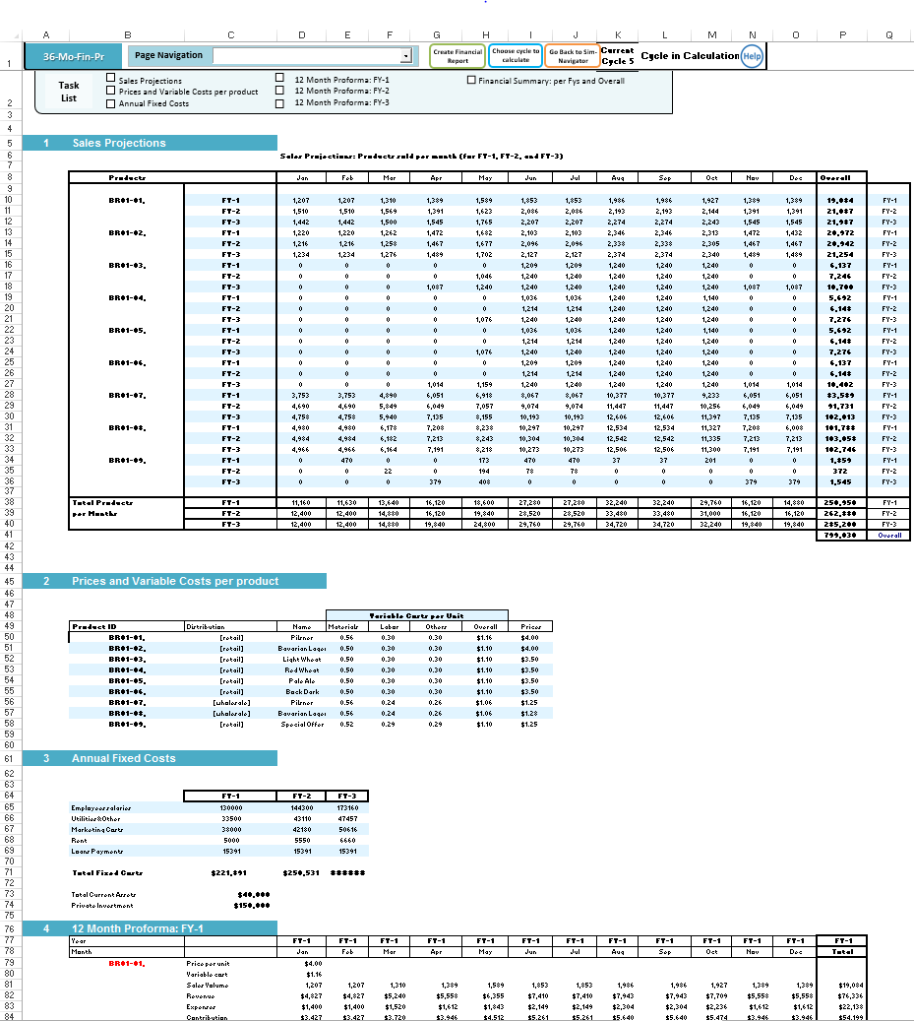

**PREPARE**

**ANALYZE**

**DECIDE**

**ANALYZE: HOW TO PLAY**

**ANALYZE: FINANCIAL STATEMENTS**

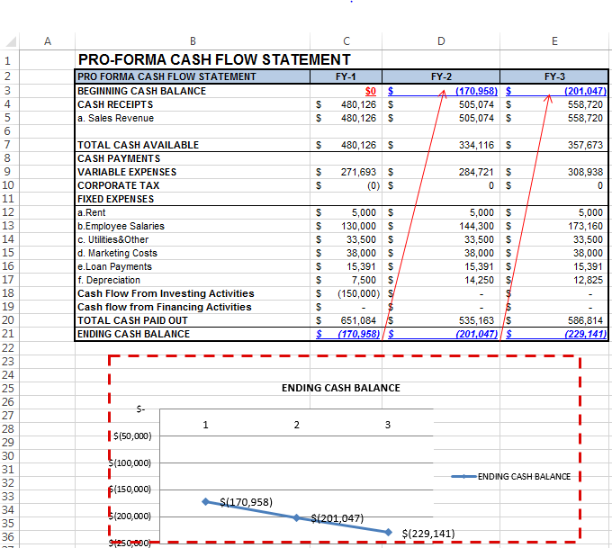

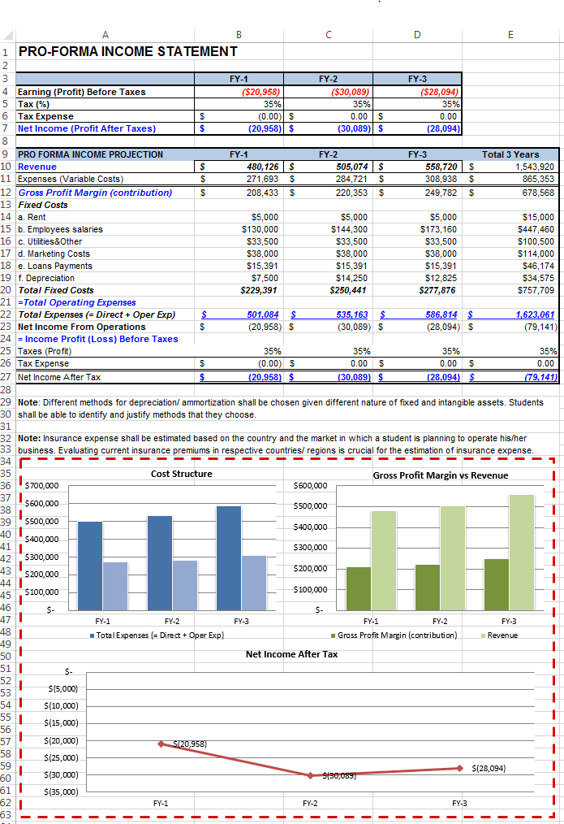

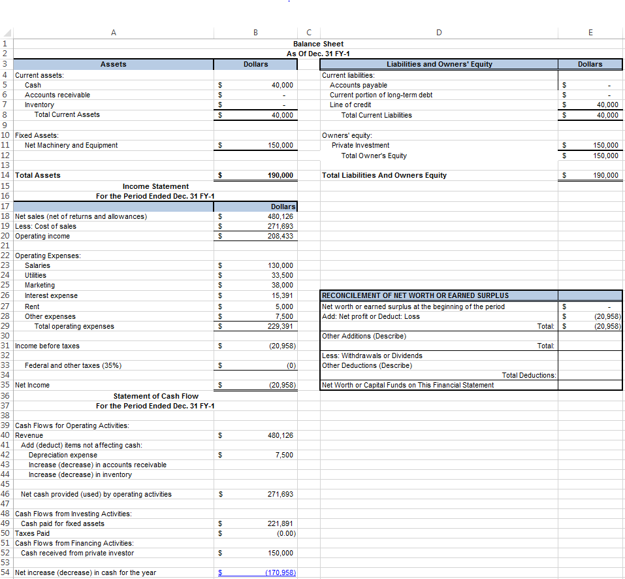

**PREPARE**

**ANALYZE**

**DECIDE**

**ANALYZE: HOW TO PLAY**

**ANALYZE: TABLE ‘D-ANALYSIS’**

Review the following Tutorials for AD715, accessible from the Course Website AD715 >>> Home Page

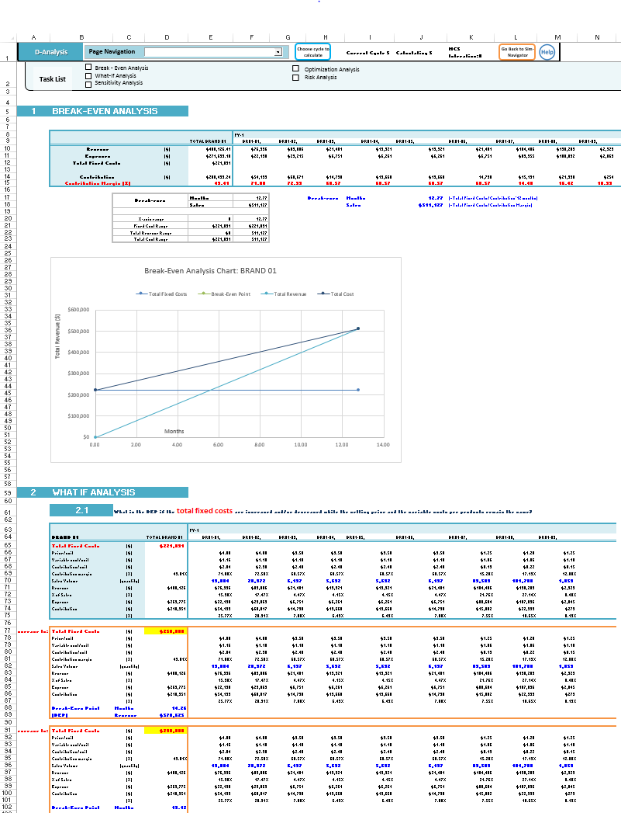

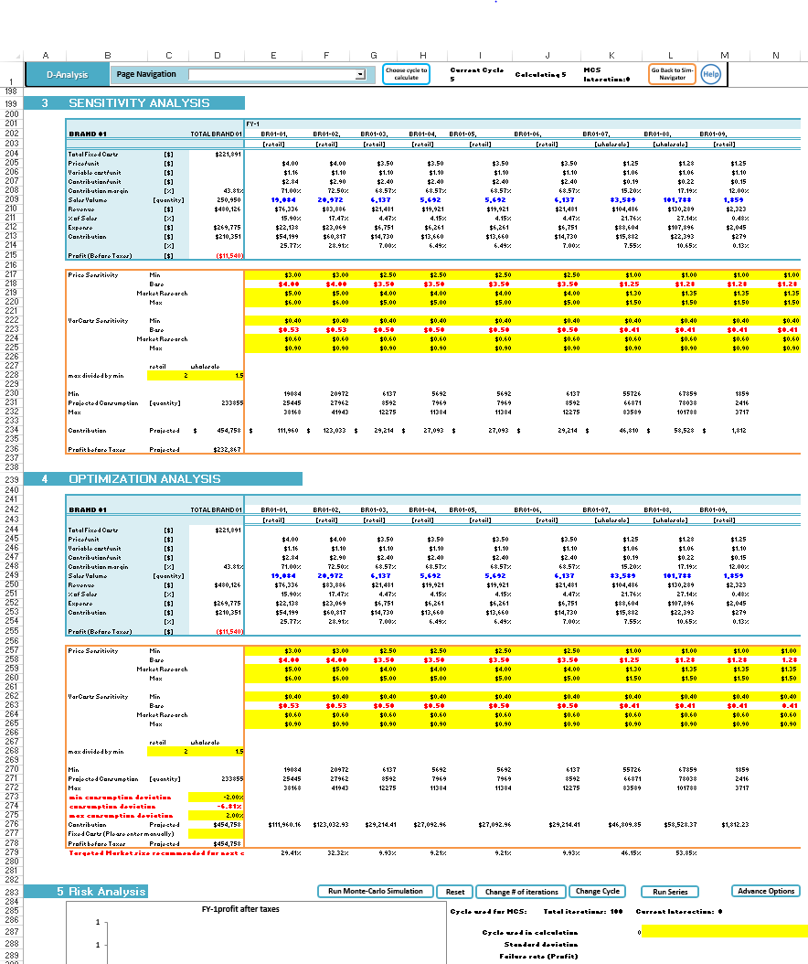

>>> **Tutorials for AD715**:

>>> Sensitivity Analysis in SensIt

>>> Optimization Analysis in RiskSolver

>>> Risk Analysis (Monte Carlo Simulation)

**PREPARE**

**ANALYZE**

**DECIDE**

**ANALYZE: HOW TO PLAY**

The process of analyzing the overall performance per decision cycles is demonstrated with the help of a ‘**Demo-Exercise PART 4: Performance Management & Decision-Making’**

**ANALYZE: TABLE ‘PERFORMANCE’**

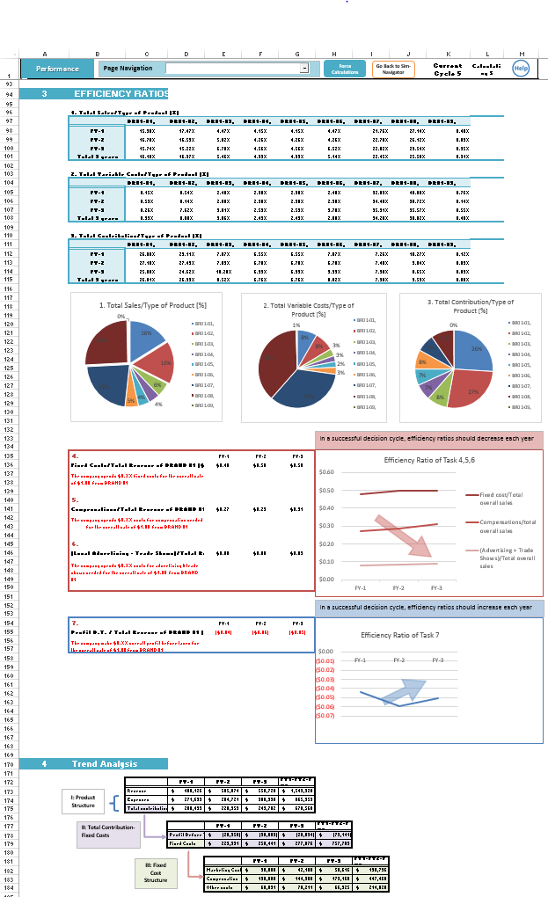

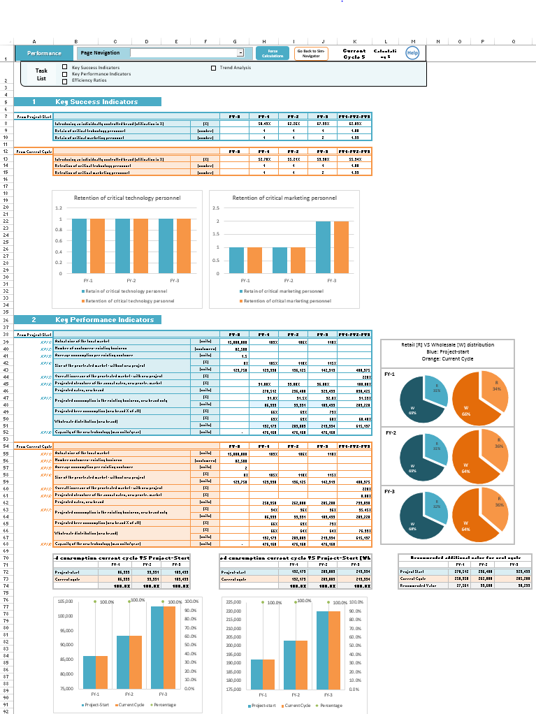

**LOCATION:**

**Course Website AD715**

>>> Assignments >>> Assignment 3

>>> Demo Exercise, **PART 4**: Performance Management & Decision-Making’ (PDF)

**PREPARE**

**ANALYZE**

**DECIDE**

**ANALYZE: HOW TO PLAY**

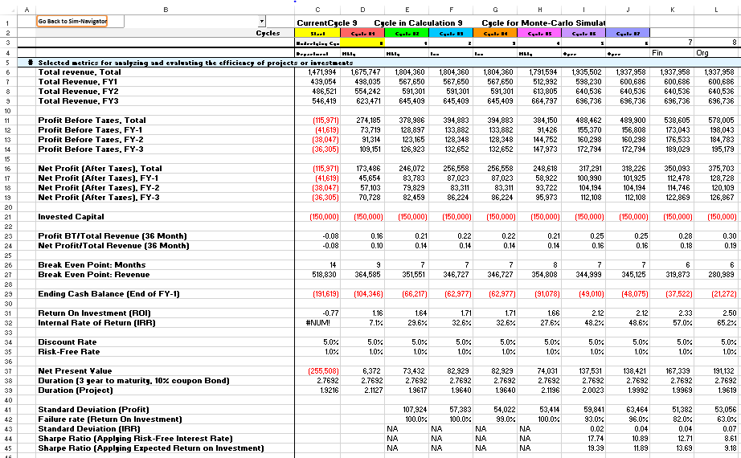

Review ‘**Demo-Exercise PART 4: Performance Management & Decision-Making’**

**ANALYZE: TABLE ‘SIM-REPORT’**

**PREPARE**

**ANALYZE**

**DECIDE**